Coal lab submission

COMMENT !
Name: Yash Raj
Roll Number : 24k-0737
!
INCLUDE Irvine32.inc

.data
str1 byte "Welcome",0
str2 byte "You should not see this line",0
str3 byte "Goodbye",0

.code
main PROC
mov edx, OFFSET str1
call WriteString
call Crlf
jmp l3
l2:
mov edx, OFFSET str2
call WriteString
call Crlf
l3:
mov edx, OFFSET str3
call WriteString
call Crlf
exit
main ENDP
end main

Output:
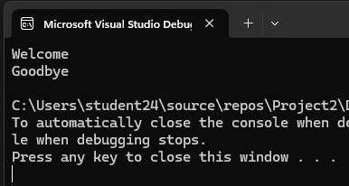

Task#2;
COMMENT !
Name: Yash Raj
Roll Number : 24k-0737
!
INCLUDE Irvine32.inc

.data

.code
main PROC
mov ecx, 15-5+1
mov eax, 5
L1:
call WriteInt
call Crlf
inc eax
LOOP L1
exit
main ENDP
end main

Output:
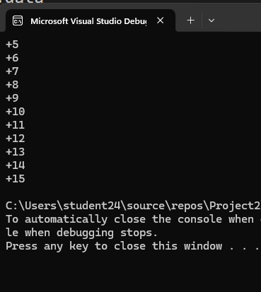

Task#3:
COMMENT !
Name: Yash Raj
Roll Number : 24k-0737
!
INCLUDE Irvine32.inc

.data
star byte 2Ah; Ascii Code for * or 42d
outloop dword ?
inloop dword ?
.code
main PROC
mov ecx, 5
mov inloop, 1
mov al, star
L1:
mov outloop, ecx
mov ecx, inloop
L2:
call writeChar
LOOP L2
inc inloop
mov ecx, outloop
call Crlf
LOOP L1
exit
main ENDP
end main

Output:
